Notes – Quiz 1

Whoo perfect score!

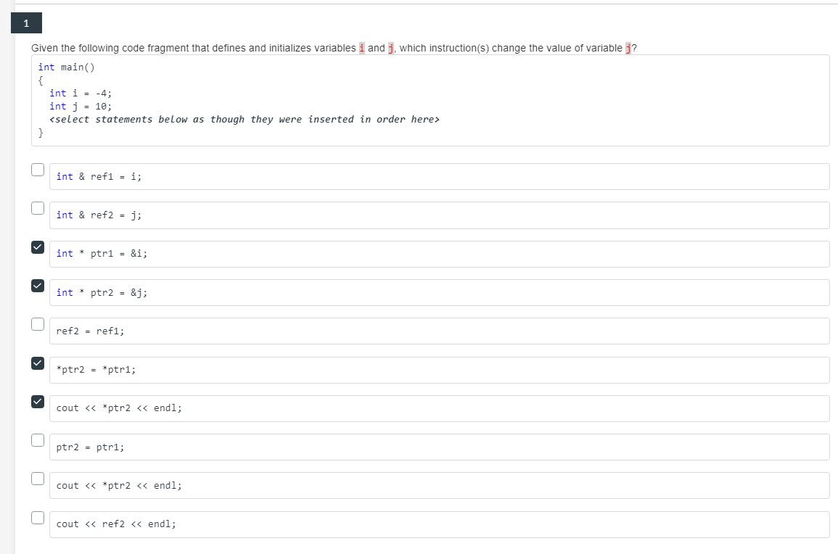

🡨 References

🡨 Overloaded functions



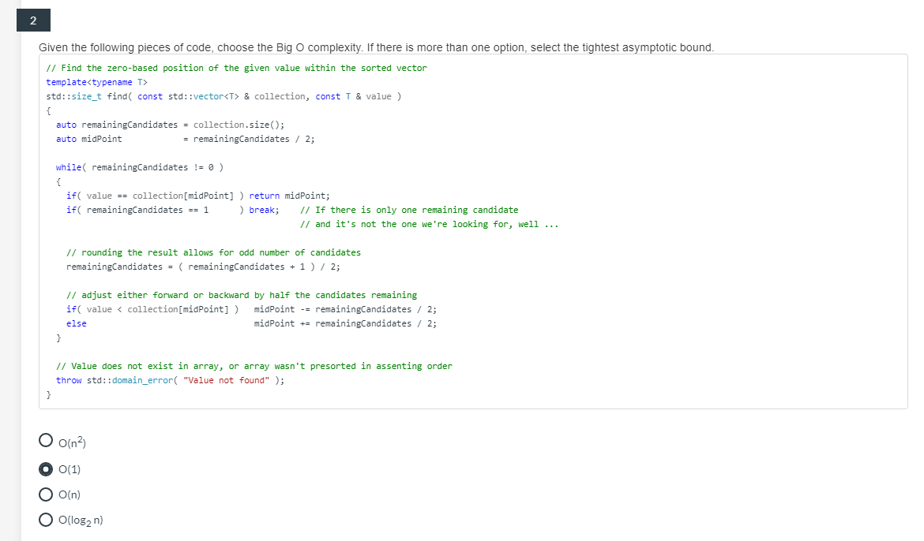



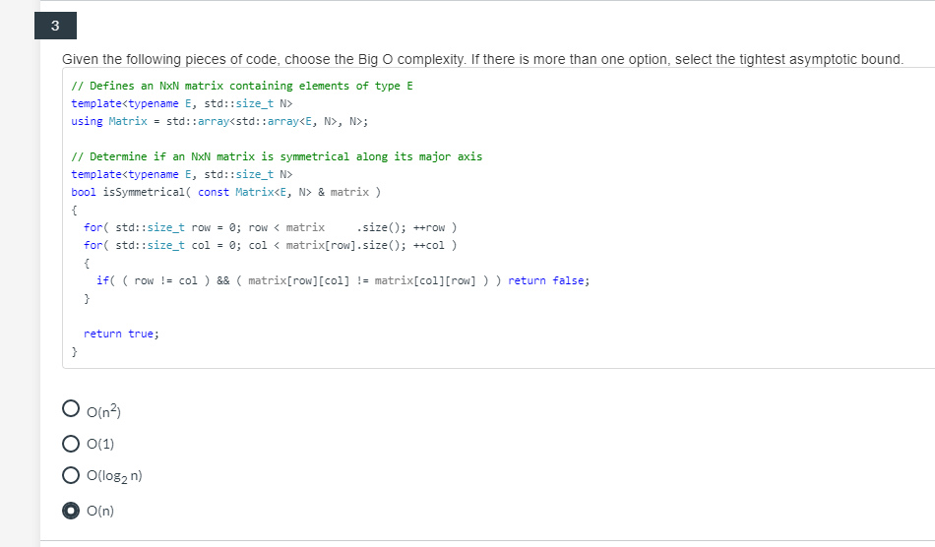



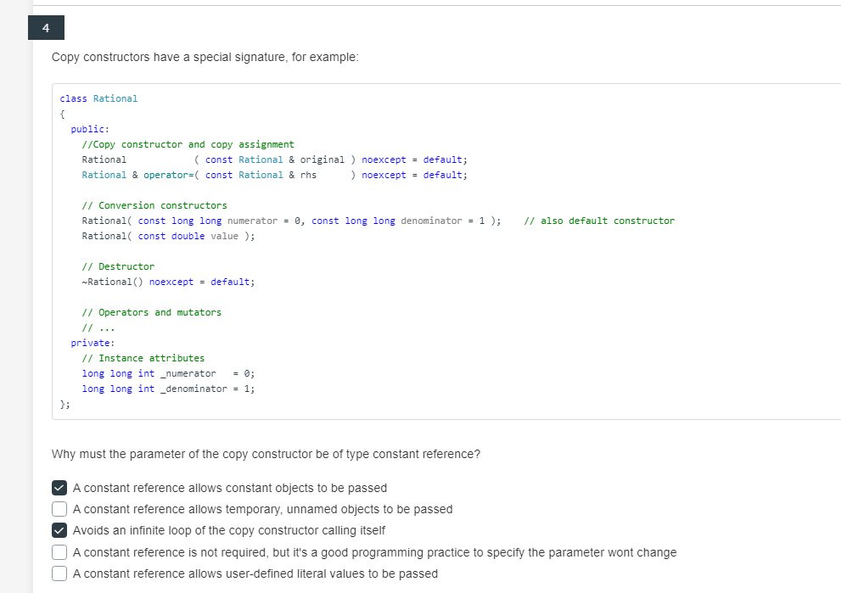







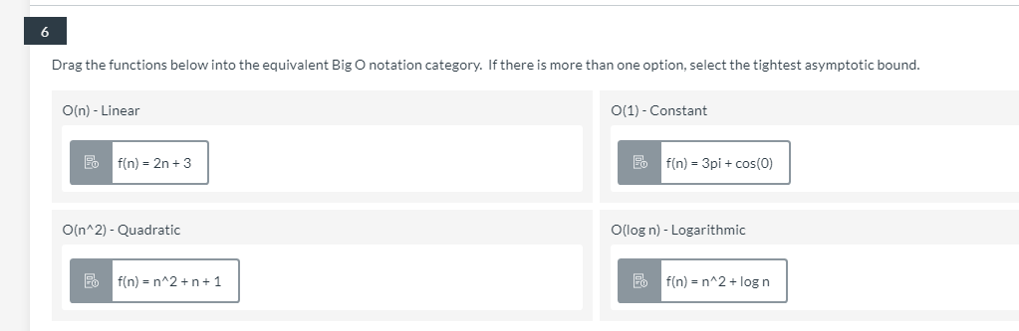



1. f(n) = 2n + 3 : Linear O(n)

2. f(n) = 3pi + cos(0) : Constant O(1)

3. f(n) = n^2 + n + 1 , f(n) = n^2 + log n : O(n^2)

4. no log n

